What is Computer Network?
A computer network is a group of computers that use of common communication protocols over digital interconnection for the purpose of sharing resource located on or provided by the network nodes.

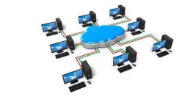
Following is the list of hardware's required to set up a computer network.
- Network Cables
- Distributors
- Routers
- Internal Network Cards
- External Network Cards
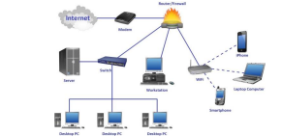
Basics Components of Computer Network
- Servers
- Clients
- Transmission Media
- Network Interface card
- Modem
- Hub
- Switch
- Cables and connectors
- Router

Type of Area Networks

LAN (Local Area Network)
MAN (Metropolitan Area Network)
WAN (Wide Area Network)
VLAN (Virtual Local Area Network)
WLAN (Wide Local Area Network)
VPN (Virtual Private Network)
CAN (Campus Area Network)
SAN (Smart Area Network)
SHAN (Smart Home Area Network)
PAN (Personal Area Network)

Difference between Internet and Intranet

Internet | Intranet
The term internet comes from the phrase international Network. | The term intranet comes from the phrase internet restriction access network.
The internet is used to share data globally. | Intranets are used to share data locally and privately.
The internet is used to provide info. That is relevant to a wide range of people. | Intranet are used to provide info. That is relevant to a single company or organization.
The internet can be accessed from anywhere as long as you have an internet connection. | Intranets can only be accessed from within the company or organization that owns it.

